**Lab 10: Finite State Machine Design**

Freddie Boadu

ECEN 328

Mansi Bhavsar

May 2, 2019

**Introduction:**

The student created a finite state machine. The student was asked to: study the characteristics of finite state machines, Create schematic designs for finite state machines using D flip flops, and test the designs on the target board.

**Materials:**

* Xilinx ISE software, student or professional edition V14.7
* Digilent Basys2 board with an XC3S100E device.

**Methods:**

The student was asked to Define the problem. This is stating what the circuit is going to accomplish. The next step was to draw a state diagram. This helps to organize the machines path as it changes states. Next bits and numbers are put to each state. This helps to create the state table which is done next. The state tables can help to create the flip flops needed for the machine. That will be the next step. That flip flops are based on the amount of inputs in the start machine. Once the table is made you can make a Kmap to simplify the solution and make a circuit using flip flops to complete the finite state machine. For the lab the students were asked to construct the circuit at the bottom of the discussion. The student was to create a new project called fsm D and create the circuit. The circuit was to be tested with The clock symbol being on BTN0.

**Data:**

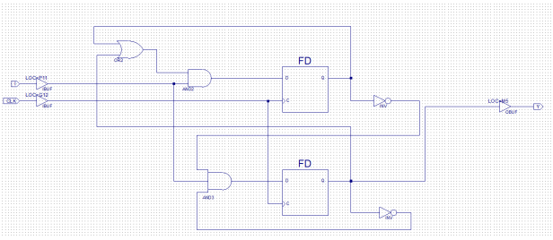

Results and discussion: The schematic was proven to be true. The input of I is fed into the circuit as well as the next states. The student will construct on from scratch in the design challenge.

**Design challenge:**

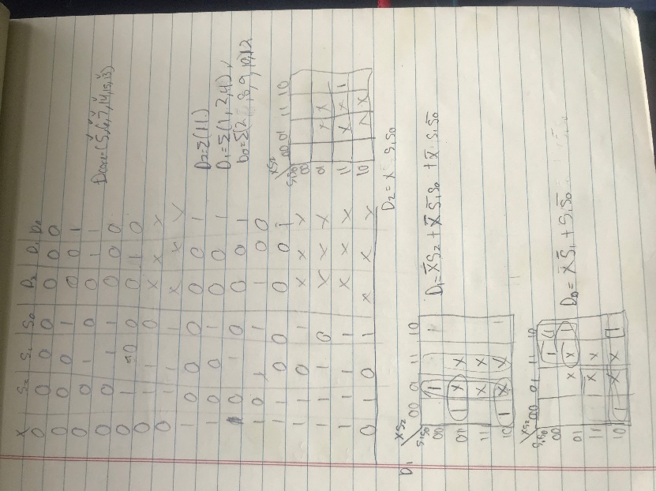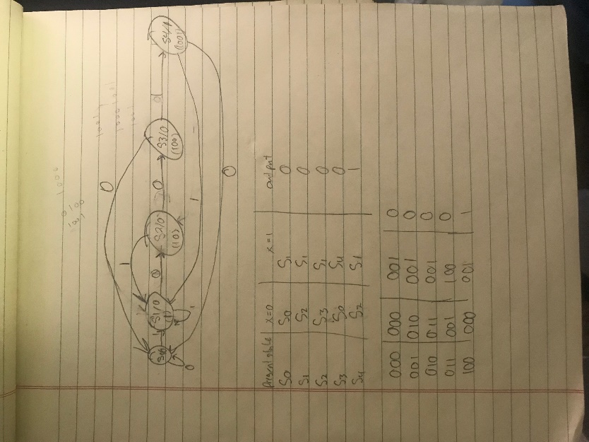

As mentioned in the result and discussion, the student made a state machine from scratch. The student had to use the sequence of 1001. The student then makes a state diagram based on the sequence. The student then uses that to make a table based on the diagram. The student then made a state table. The state table was then used to simplify the table using kmaps. The circuit consist of 2 flip flops to complete the finite state machine. (Correction D0= XS1’+S1S0’)

**Conclusion:**

The student learned how to make a finite state machine. The student learned that using a sequence can be used to make a finite state machine from scratch.